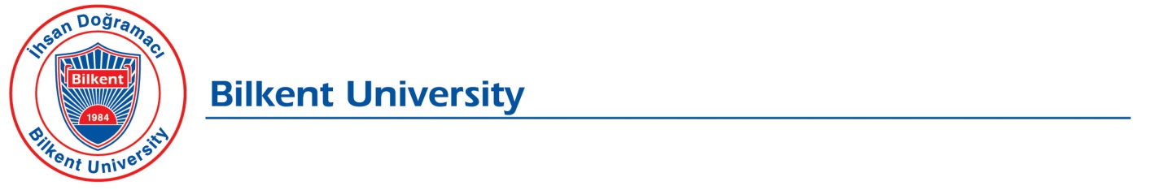
Personal Data Protection Law Application Form

Personal data owners defined as the person concerned in the Personal Data Protection Law No. 6698 (KVK Law) (hereinafter referred to as the "Applicant") have been granted the right to make certain requests regarding the processing of their personal data in Article 11 of the KVK Law.
In accordance with the first paragraph of Article 13 of the KVK Law, the applications to be made to our University, which is the data controller, regarding these rights must be submitted in writing or by other methods determined by the Personal Data Protection Board (Board).
In this context, the applications to be made to our University in writing may be made to us by printing this form and;
- With the applicant’s personal application
- By sending it to the University Registered Electronic Mail address with the signature of the applicant signed with the "Secure Electronic Signature" defined in the Electronic Signature Law No. 5070.
Below, you may find the information on the written application channels and on how to deliver the written applications to us.
Application Method | Address for Application | Information to be Specified in Application Submission
Application in person (Application by the applicant with a document certifying their identity) | İhsan Doğramacı Bilkent University  Üniversiteler Mahallesi, 06800 Çankaya, Ankara | "Request for Information within the Scope of the Law on Protection of Personal Data" shall be written on the envelope.
Application signed with "secure electronic signature" and sent via Registered Electronic Mail (REP) | bilkentuni@hs01.kep.tr | "Personal Data Protection Law Information Request" shall be written in the subject part of the e-mail.

A. Contact information of the Applicant
Your Name:
Last Name:
T.R, ID Number:
Phone Number:
E-mail:
Address:

B. Please state your affiliation with our University. (Student, alumnus, relative of the student or alumnus, business partner, employee candidate, former employee, third party company employee etc.)
- I Made a Job Application / Shared Resume
Date :……../……../…………

- I am an Employee of a Third Party Company
Please specify the company you work for and position information.
Student   Alumnus  | - Business Partner   - Other 
The unit/subject of our University with which you are in contact
Unit:………………………………………………………………………………………………......
Subject:……………………………………………………………………………………………
- I am a former employee
Years I’ve worked :

- Other :

C. Kindly indicate your request under the KVK Law in detail:

………………………………………………………………………………………………………………
………………………………………………………………………………………………………………
………………………………………………………………………………………………………………
………………………………………………………………………………………………………………
………………………………………………………………………………………………………………
………………………………………………………………………………………………………………
………………………………………………………………………………………………………………
………………………………………………………………………………………………………………

D. Kindly choose the method by which you will be notified of our response to your application:
 I want it to be sent to my address.
 I want it to be sent to my e-mail address.
This application form has been prepared in order to determine your relationship with our University, to determine your personal data processed by our University, if any, and to respond to your application in a correct and legal time. Our university reserves the right to request additional documents and information (copy of identity card or driver's license, etc.) for identification and authorization determination, in order to eliminate legal risks that may arise from unlawful and unfair data sharing and especially to ensure the security of your personal data. In the event that the information regarding your requests submitted within the scope of the form is not accurate and up-to-date or an unauthorized application is made, our University does not accept any responsibility for such false information or requests originating from unauthorized applications.
Applicant (Personal Data Owner)
Name and Last Name : ……………………………………………………
Application Date : ……………………………………………………
Signature : ……………………………………………………

